<https://www.guru99.com/python-regular-expressions-complete-tutorial.html>

## regular expression can search and extracting information from text

## While using the regular expression the first thing is to recognize is that everything is essentially a character

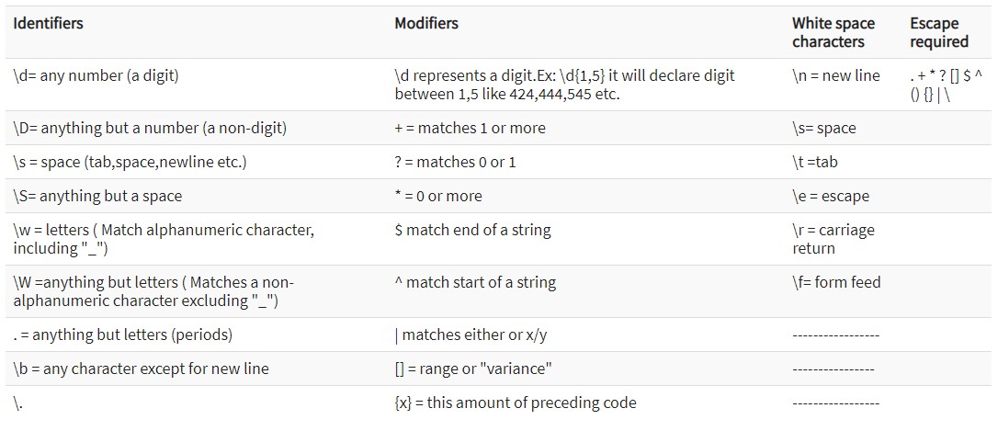

**re.match()**

**re.match()** function will search the regular expression pattern and return the first occurrence. This method checks for a match only at the beginning of the string. So, if a match is found in the first line, it returns the match object. But if a match is found in some other line, it returns null.

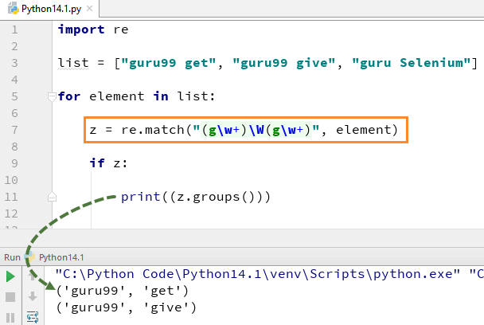

## re.search(): Finding Pattern in Text

**re.search()**function will search the regular expression pattern and return the first occurrence. Unlike re.match, it will check all lines of the input string. It returns a match object when the pattern is found and “null” if the pattern is not found

## re.findall()

**findall()** module is used to search for “all” occurrences that match a given pattern. In contrast, search() module will only return the first occurrence that matches the specified pattern. findall() will iterate over all the lines of the file and will return all non-overlapping matches of pattern in a single step.

## Flags

…